This document is merely to point out the differences in confessional count numbers between my findings and the official numbers posted on Survivor Sucks. The guidelines I use can be found [here](https://docs.google.com/document/d/18ofsPiVWxSejzSjEGlU8KEx4Og2ddEJScCV23RsCPIA/edit?usp=sharing).

**Survivor Sucks Season 40 Counts**

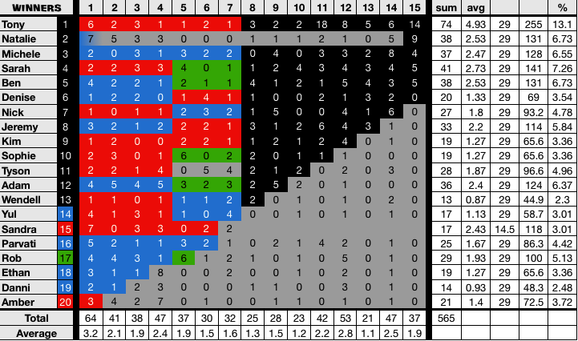

**My Season 40 Counts** ([link](https://drive.google.com/open?id=1f5It_B1QM8RRFcBe_93XPyVkDZbA-h5_mDgCRaHVlBE))

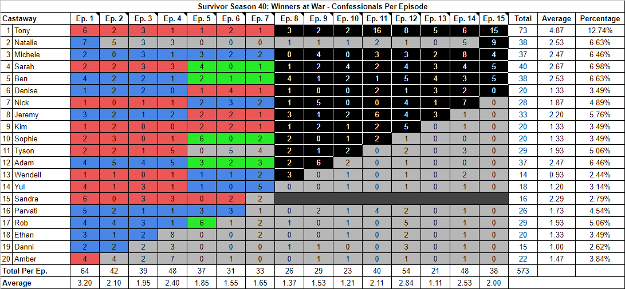

[Survivor Sucks Season 40 thread](https://www.tapatalk.com/groups/survivorsucks/survivor-winners-at-war-confessional-count-t136637.html).

**Differences**

[Episode 01](https://drive.google.com/open?id=1vifdrbrq2kkJ2yimzf3y2uvR8hV5LmyKnIxMLcBYpcA)

* **Sandra: 6 (-1)** I got a count of 6 for Sandra instead of the established 7. When Sandra gets her HII, there is a segment where she is kneeling on the sand and she is reading the note that accompanies the HII. After she reads it, she looks directly at the camera and talks directly at it, so I counted that as part of her confessional. Otherwise, if it wasn’t counted, she would have a 10+ second gap which would give her the established count of 7.
* **Amber: 4 (+1)** I got a count of 4 for Amber instead of the established 3. The confessional comes from Edge of Extinction after she is voted out.

[Episode 02](https://drive.google.com/open?id=1s_FoYoZ7puB8Ls2z1AqMu1U9EQtdn4U2pA-AEIhg18k)

* **Danni: 2 (+1)** I got a count of 2 for Danni instead of the established 1. The confessional comes from Edge of Extinction after she is voted out.

[Episode 03](https://drive.google.com/open?id=1kEwWWf9fXp__R5wwoZxR764qx1Ky9vchusx-Ag9Zmaw)

* **Ethan: 2 (+1)** I got a count of 2 for Ethan instead of the established 1. The confessional comes from Edge of Extinction after he is voted out.

[Episode 04](https://drive.google.com/open?id=19dbnUQk0Wb-WZUVp5SRpIDXUFLBuhaUfkERU7edm850)

* **Tyson: 5 (+1)** I got a count of 5 for Tyson instead of the established 4. The confessional comes from Edge of Extinction after he is voted out.

[Episode 06](https://drive.google.com/open?id=1m0Su0vMFS5IilmUJ_K_3-2iCRDDV61dbpRJZt9eligM)

* **Parvati: 3 (+1)** I got a count of 3 for Parvati instead of the established 2. Parvati receives the Idol Nullifier advantage and you can clearly see she is sitting down for an interview with a producer. The camera is fixed on her on two different occasions, so I included this as a confessional.

[Episode 07](https://drive.google.com/open?id=1zsqctwldid9Jw6-b4I_MKXyAxjY6f8nY5W67uMZ0lSQ)

* **Yul: 5 (+1)** I got a count of 5 for Yul instead of the established 4. The confessional comes from Edge of Extinction after he is voted out.

[Episode 08](https://drive.google.com/open?id=1NMZYLmL0c7sYni6MXvSS_Pds1EKMfU9eUzXRF1bCAhA)

* **Wendell: 3 (+1)** I got a count of 3 for Wendell instead of the established 2. The confessional comes from Edge of Extinction after he is voted out.

[Episode 09](https://drive.google.com/open?id=1B8UrwyvoAacPkGlUcQiQUu185laNLjGVlv2WJHjCwTE)

* **Adam: 6 (+1)** I got a count of 6 for Adam instead of the established 5. The confessional comes from Edge of Extinction after he is voted out.

[Episode 11](https://drive.google.com/open?id=1rff2r0z-HJMx8E9LIWRq03eD1dB6xYKEaE2diTnP2ic)

* **Sarah: 2 (-1)** I got a count of 2 for Sarah instead of the established 3. This comes from an on-the-fly segment where Sarah talks directly to the camera as she paints and narrates. Excluding this segment would give Sarah a count of 3.
* **Tony: 16 (-2)** I got a count of 16 for Tony instead of the established 18. It all comes from a combination of on-the-fly segments intertwined with interviews. Tony addresses the camera multiple times. If these segments were excluded, Tony would have a count of 18.
* **Sophie: 2 (+1)** I got a count of 2 for Sophie instead of the established 1. The confessional comes from Edge of Extinction after she is voted out.

[Episode 12](https://drive.google.com/open?id=1GVnw538DqCbPOuJFVjYb5eoJPZQoaiO20xcjewFhQic)

* **Kim: 5 (+1)** I got a count of 5 for Kim instead of the established 4. The confessional comes from Edge of Extinction after she is voted out.

[Episode 14](https://drive.google.com/open?id=1LnunARl1a9XkheDFxbM8l5hmTmmWQfz9W6q6bep8iF4)

* **Nick: 7 (+1)** I got a total of 7 for Nick instead of the established 6. The confessional comes from Edge of Extinction after he is voted out which also happened in a 2-hour episode and before the final credits appeared.

[Episode 15](https://drive.google.com/open?id=1iHVFa8N9PtqRHbjhNeQu9TcJJ-PUahwPK-mhfEHS1Qo)

* **Tony: 15 (+1)** I got a total of 15 confessionals for Tony instead of the established 14. The extra confessional comes from an on-the-fly segment in which Tony climbs down a tree and talks directly to the camera.

**No Change**

* [Episode 05](https://drive.google.com/open?id=1bBvPtCnlkfdWHvBEvBdXYC-DTgcO8JbWCg8mJWryH1w)
* [Episode 10](https://drive.google.com/open?id=1DeHdsNYGKj59U182UY3WanrE0HAI0NNQgDhoB4NIOh8)
* [Episode 13](https://drive.google.com/open?id=1XfqbumFEGEvifLrlN06hMoureyiMAJxXnDe2K25nSP0)

|  |  |  |
| --- | --- | --- |
| **Castaway** | **Count (EoE in parenthesis)\*** | **Change** |
| Tony | 73 | +1 |
| Sarah | 40 | -1 |
| Nick | 27 + (1) = 28 | +1 |
| Kim | 19 + (1) = 20 | +1 |
| Sophie | 19 + (1) = 20 | +1 |
| Tyson | 28 + (1) = 29 | +1 |
| Adam | 36 + (1) = 37 | +1 |
| Wendell | 13 + (1) = 14 | +1 |
| Yul | 17 + (1) = 18 | +1 |
| Sandra | 16 | -1 |
| Parvati | 26 | +1 |
| Ethan | 19 + (1) = 20 | +1 |
| Danni | 14 + (1) = 15 | +1 |
| Amber | 21 + (1) = 22 | +1 |
| **Total** | **573** | **+8** |

*\*In this column, the number in parenthesis corresponds to any post TC EoE confessionals I counted, and the equal corresponds to my final total for that castaway, which is also reflected in the overall change in the third column. If you don’t count EoE confessionals, the total number for the castaway will be to the left of the parenthesis.*